# Brief Use Cases

## Use case 1: Maintain profile

An employee is hired by an employer which gives the employee an access to enrol in benefits provided by the employer. The admin creates an account for the employee and gives him access to the application. The Employee logs in to the application and enters his information into the database. After logging in to the system, he will see a portal giving an option to view his profile. This gives him access to edit and delete details in this profile. This information is stored in the database which can be accessed by the management.

## Use case 2: Configure System

Initial installation of the system requires several dependencies, such as installing the database driver, and several options of database platforms, and the kind of OS based on the product’s owner’s interests and construct modules for SSH transfer protocol. Additionally, the system will create a dedicated system admin, where the user name and password are defined by the user who is running this process from the prompt.

## Use case 3: Make Election

As the employee gets his account in the system, he is eligible to make elections for his benefits. He can choose three different elections eligibilities; Open enrolment (OE), Qualified Life Event (QLE), and New Hires (NH).

## Use case 4: Maintain Account for Employee

At a security point of view, access given to the employee must be restricted to only current employee’s and not ex-employees. So, an admin creates certain access, update and revoke protocols to the system.

## Use case 5: Check Status

## As the employee is logged in to the system, he will get an option to view his status. This option gives him the capability to check the status of an election such approval, expiration date, and beneficiaries enrolled under a specific benefit.

## Use case 6: Validates Employee Information

The management has certain restrictions to handle qualified life event. They must verify certain documents before allowing an employee to register for the qualified life event. The management can either approve or deny certain elections for an employee or a beneficiary after verifying their documents.

## Use Case 7: Generate BI reporting

Management uses this system as a reporting tool to view several managerial reports that are meaningful for the business, such count of employees that are enrolled with specific vendors, or amount of money that the employee or the employer contributed too.

## Use case 8: Notify Vendors

The management uses this functionality to notify a vendor with the list of employees that have selected the vendor’s plan, which eliminates the previously followed manual process of notifying the vendors.

## Use case 9: Notify Payroll

Management uses this functionality to update payroll system and notify payroll staff to streamline payroll deductions for such benefits of an employee.

## Use case 10: Summarises Account

This option was introduced to give transparency to an employee about his salary. After logging in to the system, he can see an option called Account Summary. This will show him his total salary and deduction after enrolling to any election.

## Use case 11: Handle payment Authorization

This option gives management full control to accept or deny the benefits he is about to enrolled. The management has an option to view the election form of an employee and gives authorization to the payment. This way the management can track the amount the company has to pay for certain employee.

## Use case 12: Manage Vendors

If the vendors go out of business or many be there is some problem with certain employee. The management has an option to either remove him or make changes to his information. Management can define, add, update, and delete vendors to facilitate employee’s elections, payroll deductions, and data exchange.

# Use Case Diagrams:

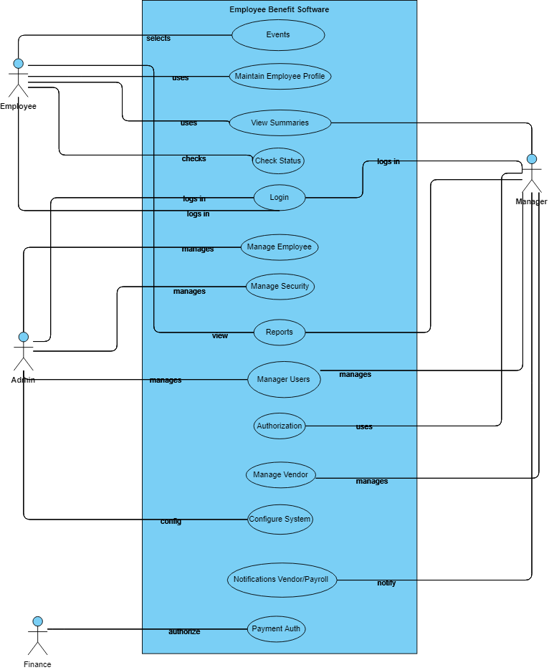

Figure: Overview of System

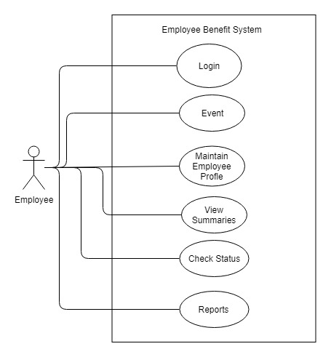

Figure 1: Use Case Diagram for Employee Interaction with the system.

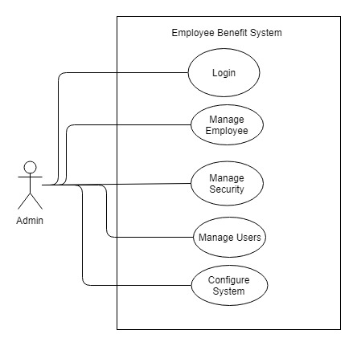

Figure 2: Use Case Diagram for Admin

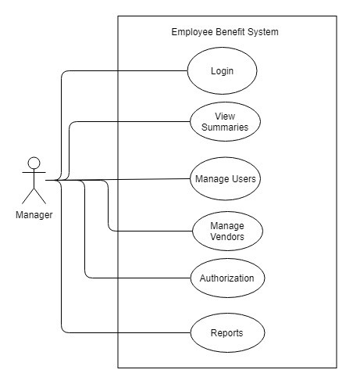

Figure 3: Use Case Diagram for Manager.

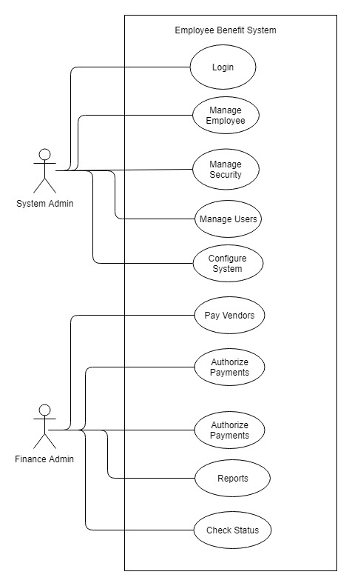

Figure 4: Use Case Diagram of System Admin and Finance Admin.

# Relations among Uses Cases:

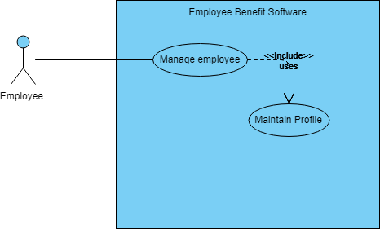

Figure 5: Manage Employee uses Maintain profile

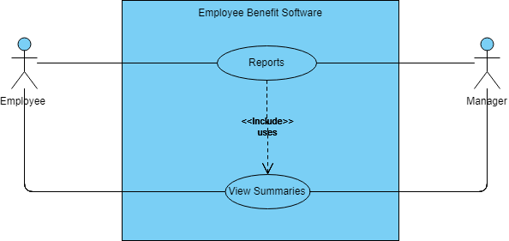

Figure 6: Use Case Reports use View Summary by employee and manager